# Assignment -3

**IBM Object Storage and IBM Watson Assistant**

|  |  |
| --- | --- |
| Assignment Date | 28 October 2022 |
| Student Name | Gowritejesh A P |
| Student Roll Number | AC19UEC046 |
| Maximum Marks | 2 Marks |

# Question 1:

Create a Bucket in IBM object storage.

# Solution:

**ibmCloudTest.py** import ibm_boto3 from ibm_botocore.client import Config, ClientError from ibm_s3transfer.aspera.manager import AsperaTransferManager from ibm_s3transfer.aspera.manager import AsperaConfig from flask import Flask, render_template, url_for, request, redirect

COS_ENDPOINT="https://s3.jp-tok.cloud-object-storage.appdomain.cloud" COS_API_KEY_ID="wprEMAxyjHj5sPI959wL_3HJczOWRbYn52XUuLrDSJON"

COS_INSTANCE_CRN="crn:v1:bluemix:public:cloud-object- storage:global:a/602bcedcf9224f7b8c2e1aed60258292:b846251f-3216-44c8-b123-4e13e3571cda::"

cos = ibm_boto3.resource("s3", ibm_api_key_id=COS_API_KEY_ID, ibm_service_instance_id=COS_INSTANCE_CRN, config=Config(signature_version="oauth"), endpoint_url=COS_ENDPOINT

)

ms_transfer_config = AsperaConfig(multi_session=2, multi_session_threshold_mb=100) transfer_manager = AsperaTransferManager(client=client, transfer_config=ms_transfer_config)

app=Flask( name )

bucket_name = "flask-application" download_filename

= "E:\IMS\static\css\Styles.css" object_name = "Styles.css"

with AsperaTransferManager(client) as transfer_manager:

future = transfer_manager.download(bucket_name, object_name, download_filename) future.result()

def get_item(bucket_name, item_name):

print("Retrieving item from bucket: {0}, key: {1}".format(bucket_name, item_name)) try:

file = cos.Object(bucket_name, item_name).get() print("File Contents: {0}".format(file["Body"].read())) except ClientError as be:

print("CLIENT ERROR: {0}\n".format(be)) except Exception as e:

print("Unable to retrieve file contents: {0}".format(e))

def get_bucket_contents(bucket_name):

print("Retrieving bucket contents from: {0}".format(bucket_name)) try:

files = cos.Bucket(bucket_name).objects.all() files_names = []

print(files) for file in files:

files_names.append(file.key) print("Item: {0} ({1} bytes).".format(file.key, file.size)) return files_names except ClientError as be:

print("CLIENT ERROR: {0}\n".format(be)) except Exception as e:

print("Unable to retrieve bucket contents: {0}".format(e))

@app.route('/') def index():

files = get_bucket_contents('flask-application') return render_template('index.html', files = files)

if name ==' main ': app.run(debug=True)

# Output:

**Question 2:**

Upload 5 images to ibm object storage and make it public. write html code to displaying all the 5 images.

# Solution: index.html

<h1>IBM Cloud Storage and IBM Watson Assistant</h1>

<br><hr>

{% block head %}

<!-- CSS -->

<link rel="stylesheet" href="{{ url_for('static',filename='css/Styles.css') }}" /> {% endblock %}

<script> window.watsonAssistantChatOptions = { integrationID: "8abe6aef-f2bb-4376-be93- 7fda1857ec36", // The ID of this integration. region: "jp-tok", // The region your integration is hosted in. serviceInstanceID: "440aaee1-fbb4-4c2b-8604-cb5d605fa157", // The ID of your service instance.

onLoad: function(instance) { instance.render(); }

};

setTimeout(function(){ const t=document.createElement('script');

t.src="https://web-chat.global.assistant.watson.appdomain.cloud/versions/" + (window.watsonAssistantChatOptions.clientVersion || 'latest') + "/WatsonAssistantChatEntry.js";

document.head.appendChild(t);

});

</script>

<!doctype html>

<html>

<body>

{% for row in files %}

<div style="border: 1px solid #EFEFEF;margin:10px;">

<h3>Filename : {{row}} </h3>

<img src="https://flask-application.s3.jp-tok.cloud-object-storage.appdomain.cloud/{{row}}" width="150px"></td>

</div>

{% endfor %}

</body>

</html>

# Output:

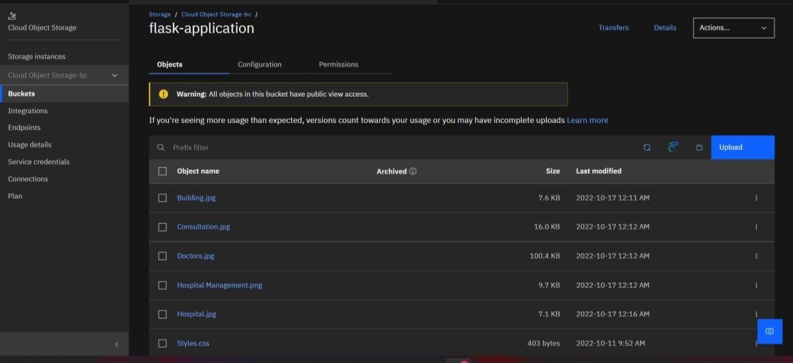

**Question 3:**

Upload a css page to the object storage and use the same page in your HTML code.

**Solution: Styles.css** body { background-color: rgb(190, 229, 247); text-align: center; font-style: italic ;

}

.outercont

{

height: 100vh; width: 100vw; display: flex; flex- direction: column; justify- content: space-around; align- items: center;

}

p { font-size: 20px;

}

h1 { text-align: center; font-style: normal;

}

h2 { text-align: center;

}

.cont { width:

700px;

}

.leftcont { font- size: 17px;

}

.rightcont { font- size: 17px;

}

.othercont { display: flex;

}

# Output:

**Web Page:**

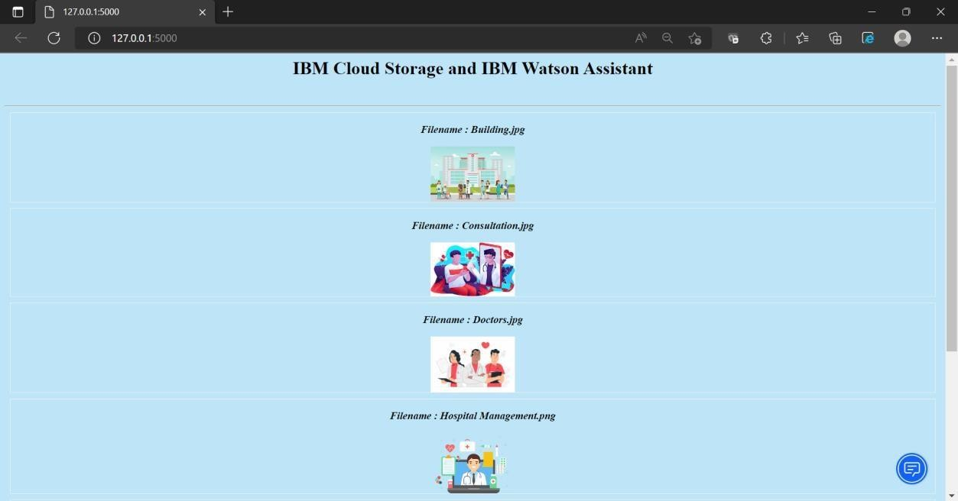

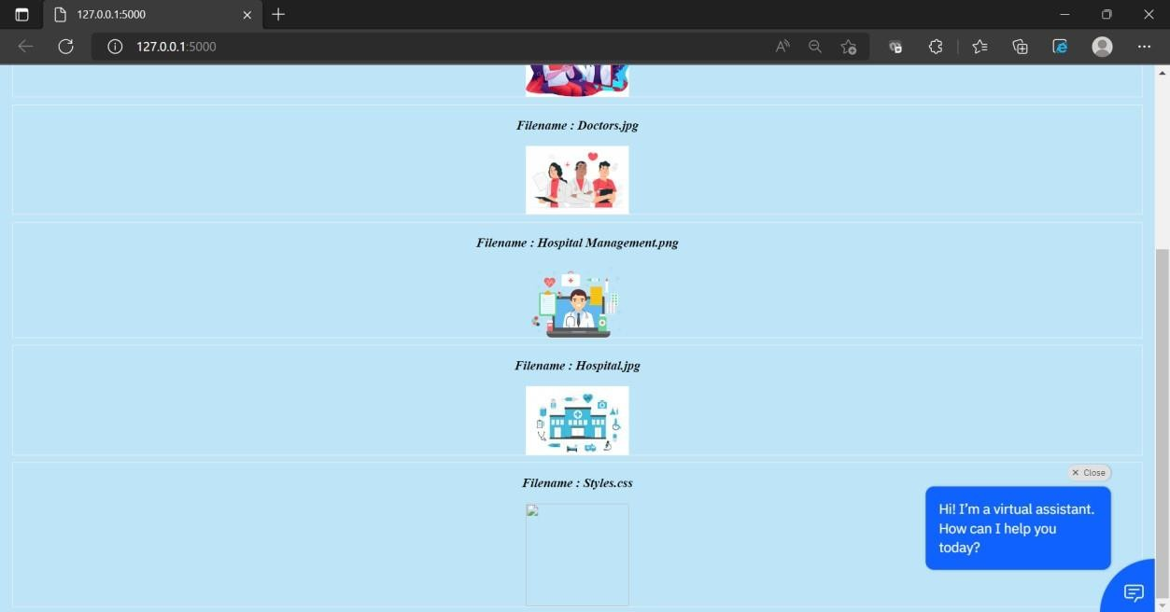

# Question-4:

Design a chatbot using IBM Watson assistant for hospital. Ex: User comes with query to know the branches for that hospital in your city. Submit the web URL of that chat bot as a assignment.

# Solution:

*https://web- chat.global.assistant.watson.appdomain.cloud/preview.html?backgroundImageURL=https%3A%2F% 2Fjp-tok.assistant.watson.cloud.ibm.com%2Fpublic%2Fimages%2Fupx-440aaee1-fbb4-4c2b- 8604cb5d605fa157%3A%3Affa26b03-3295-42fd-a098-6723615c4e58&integrationID=a3e3b932- 8ee443ee-9ccb-f3cfa9687188&region=jp-tok&serviceInstanceID=440aaee1-fbb4-4c2b- 8604cb5d605fa157*

# Output:

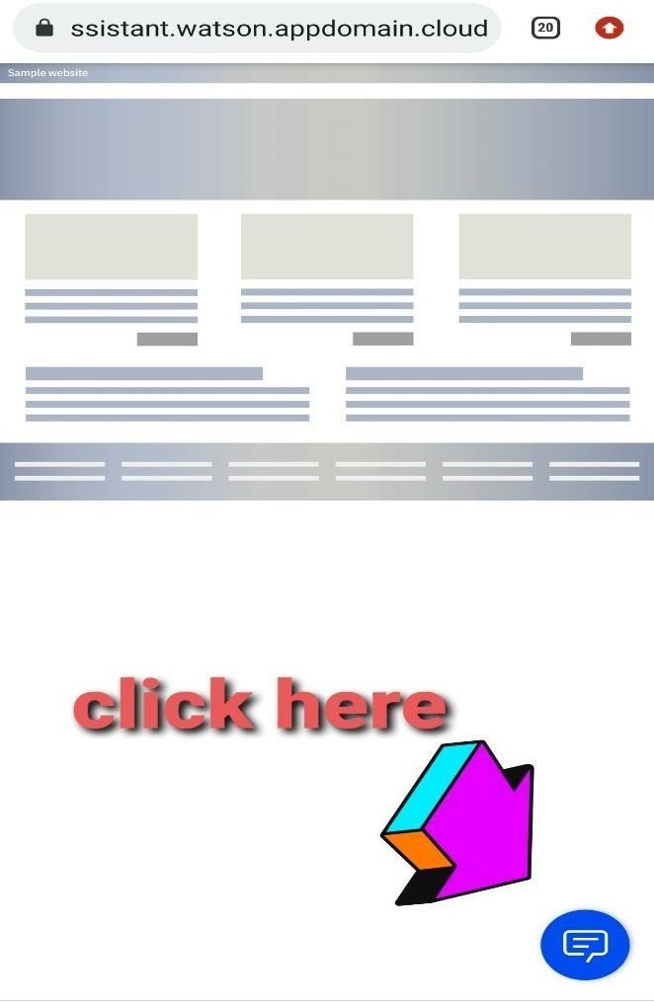 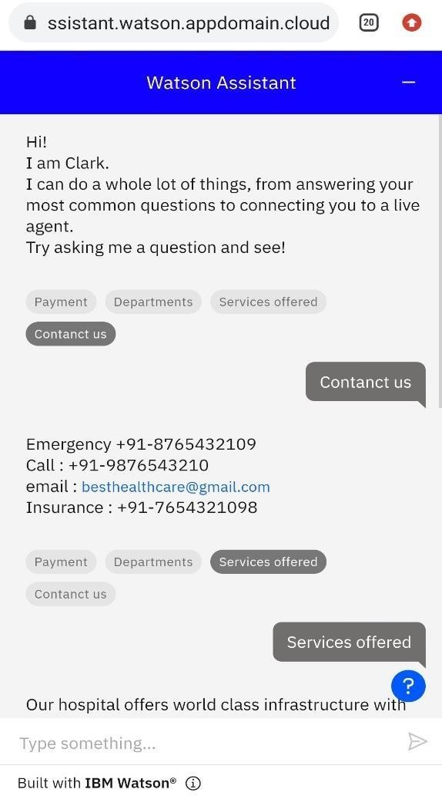

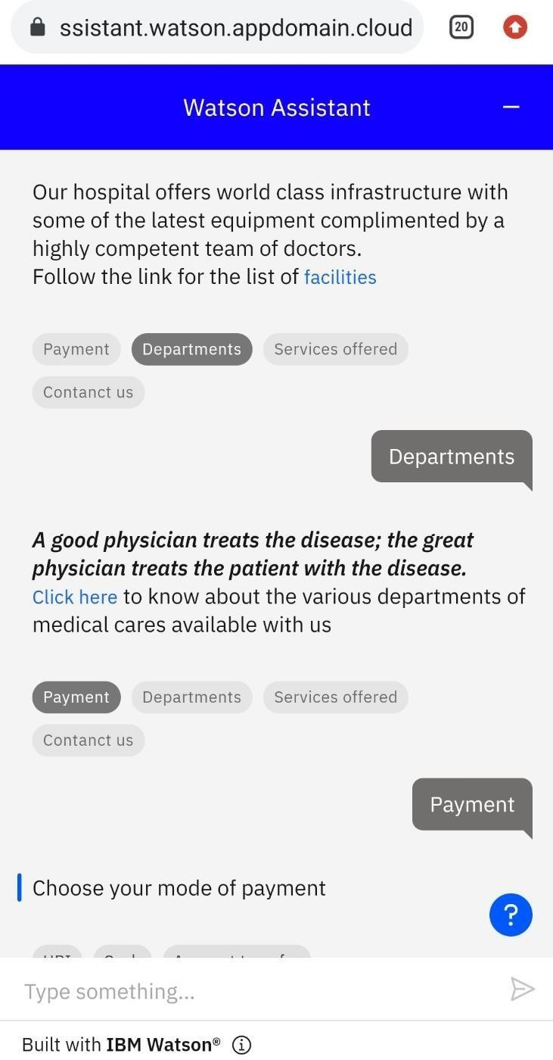 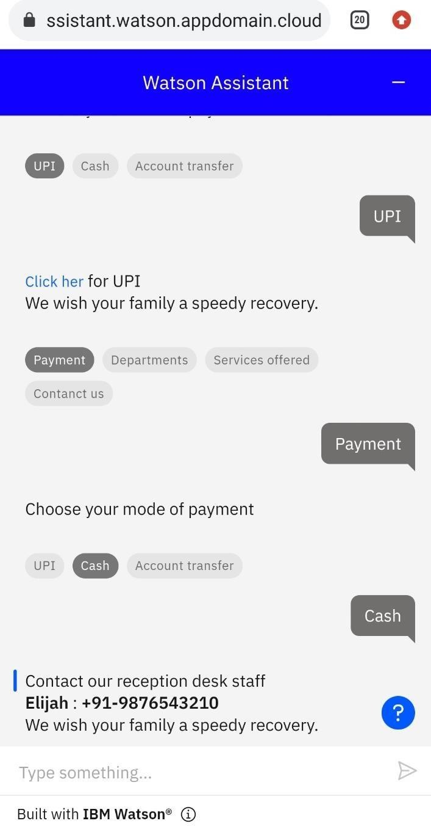

# Question-5:

5.Create Watson assistant service with 10 steps and use 3 conditions in it. Load that script in HTML page.

**Solution:**

<script> window.watsonAssistantChatOptions = { integrationID: "8abe6aef-f2bb-4376-be93- 7fda1857ec36", // The ID of this integration. region: "jp-tok", // The region your integration is hosted in. serviceInstanceID: "440aaee1-fbb4-4c2b-8604-cb5d605fa157", // The ID of your service instance. onLoad: function(instance) { instance.render(); }

};

setTimeout(function(){

const t=document.createElement('script');

t.src="https://web-chat.global.assistant.watson.appdomain.cloud/versions/" + (window.watsonAssistantChatOptions.clientVersion || 'latest') + "/WatsonAssistantChatEntry.js"; document.head.appendChild(t);

});

</script>

# Steps:

Steps in payment Steps in location

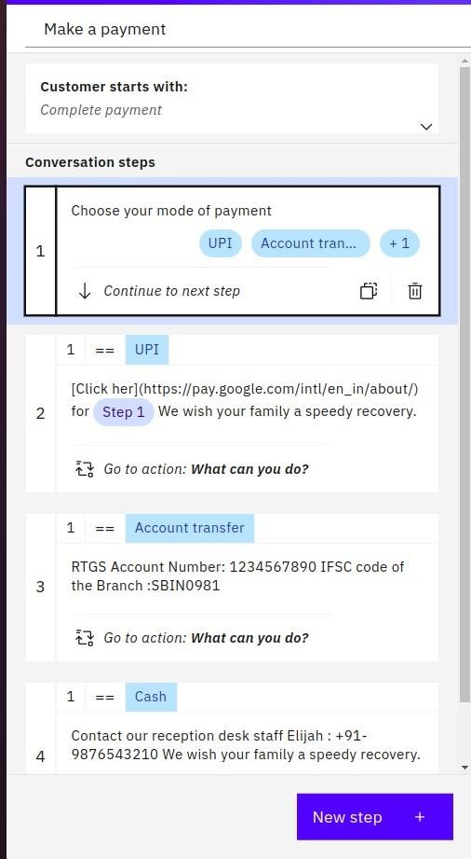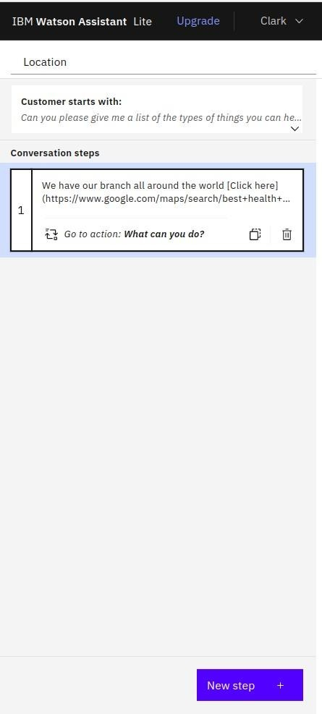

steps in What can you do

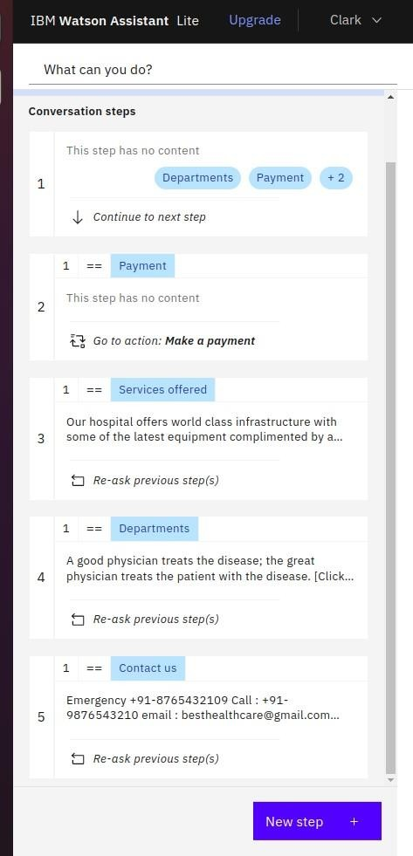

# Conditions:

Conditions in payment

* UPI
* Account transfer
* Cash

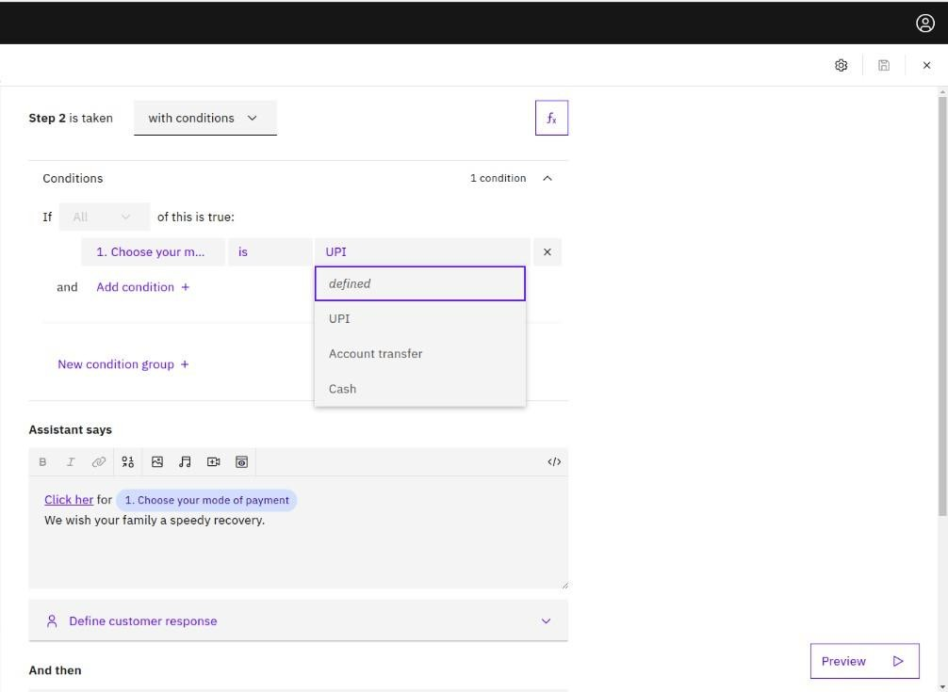

Conditions in What can you do

* Departments
* Payment
* Services offered
* Contact us

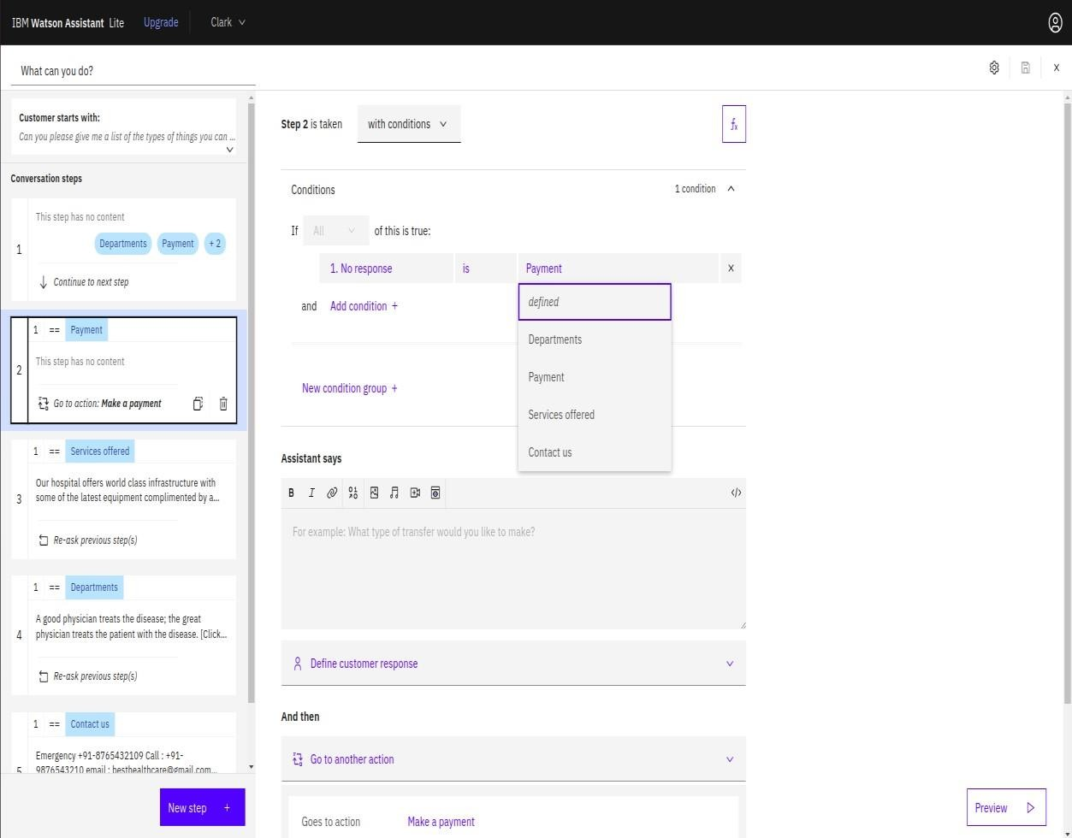

# Output:

